How to Sign-In For Events at the Haddam Senior Center Using SchedulesPlus

From your phone, tablet or computer:
Go to your browser (the icon that takes you to the internet) either Safari, Chrome, Firefox, Duck Duck Go etc. (Chrome is preferred) and type in https://schedulesplus.com/haddam and select Enter.
- Tip: If you are able to, I suggest you bookmark the url (website) so you can easily call it up as needed. There are several ways to do this depending on which browser you are using. If you need help with this, please let Doreen know.

The landing page should look like this:
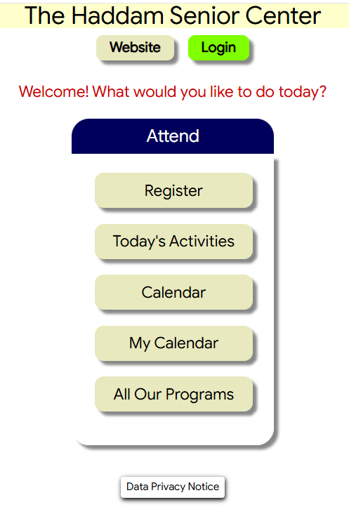
Select the green Login button
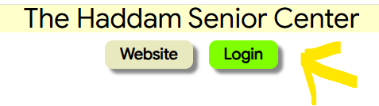
In the next screen, you will enter your phone number. It can be all ten numbers, or the last seven. Once entered, select the green Search button.
*Note: If your name doesn’t appear, doublecheck that you have entered the correct number. If I have both your cell number and landline number, you can enter either.
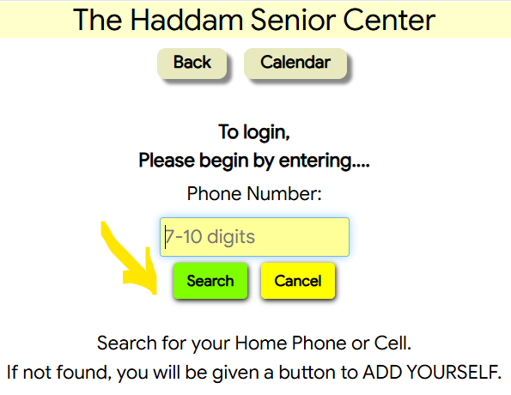
Once you’ve entered your number and Search, your name will appear in the yellow box. Select your name and you are now logged in!
*Note: If you and a spouse share a phone number, both of your names will appear separately.
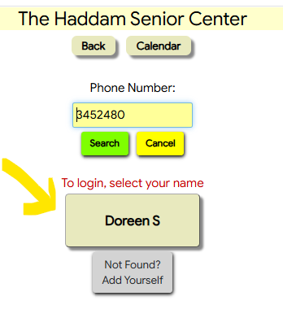

The easiest way to select an event/lunch is through the Calendar. Select the Calendar button as shown below.
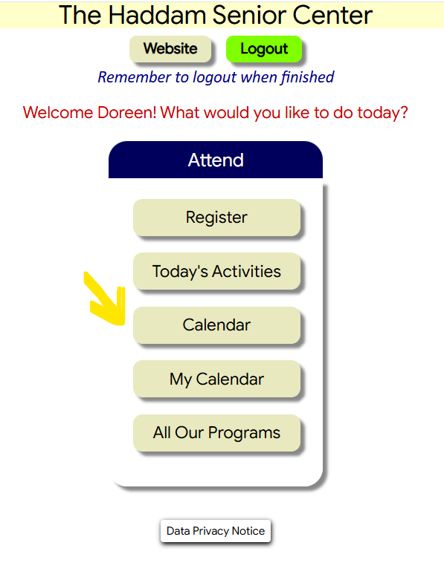
All of the events listed in the calendar include a clickable link to register for the event you want to attend. Not all events require advanced reservation. If you select one of these, it will simply bring up the event with no place to register. Click the calendar button at the top of the screen, and it will return you to the calendar as shown below.
To register for lunch or an event, click the link for the lunch/event on the date and time you want. 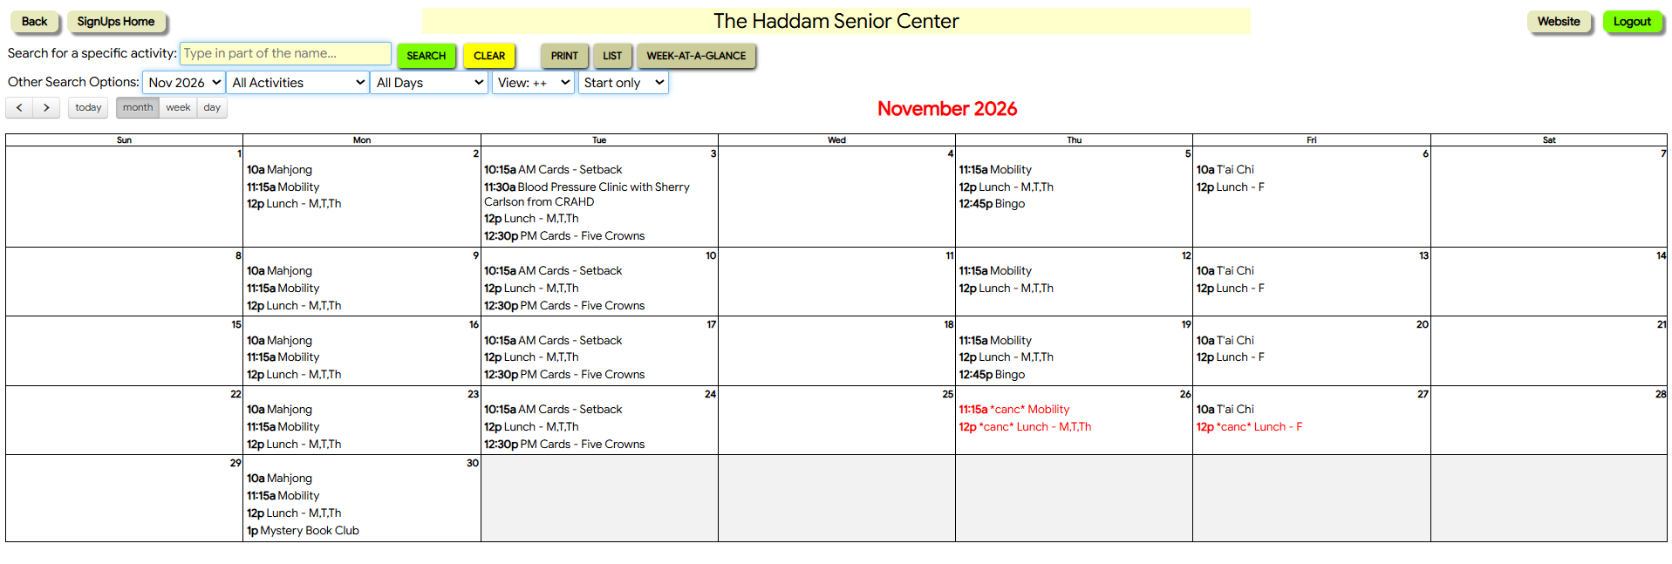

The following screen will come up. Confirm it is the correct date and time, and select the blue Sign Up Now button in the lower left.
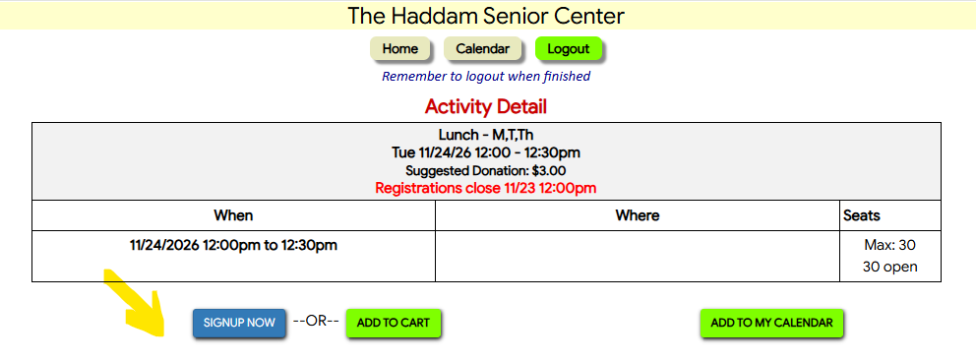

The system will ask you to confirm that this is the event you want to sign up for, select Yes, Sign-Up.
*Note: The lunches are set up as “Lunch - M,T,Th” as the name for every Monday, Tuesday and Thursday lunch. In this screen you are only selecting one day, either a Monday, Tuesday or a Thursday, not all three. Friday lunch events are set up as “Lunch – F”.
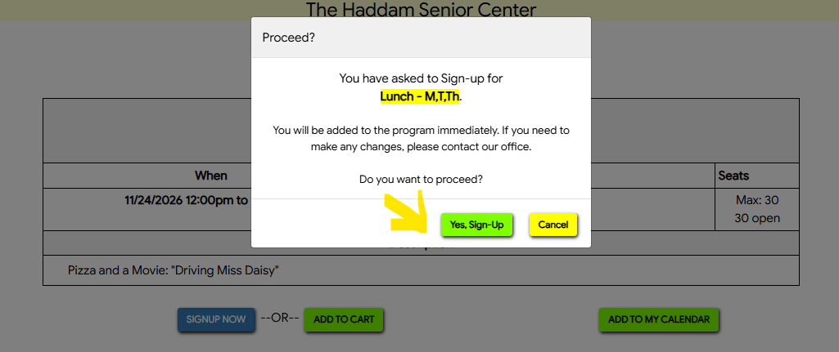

The next screen let’s you know that you are confirmed on the date you selected. If this is incorrect, there is an option to cancel the reservation in red. If the information is correct, you are done!
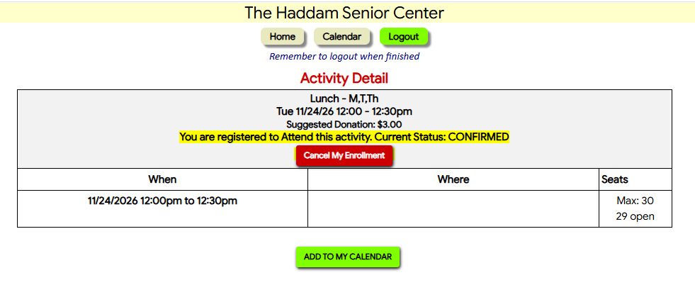
You can then select Calendar to register for another lunch or event, or select the green Logout button in the upper right to log out of the website.

Using the Week-at-a-Glance View to Register for Lunch and Events:
As with most things, there are multiple ways to register for lunch and events. If you have trouble clicking the link using the calendar view, you can also register using the Week-at-a-Glance view in Calendar. You will use the steps above to get to the calendar view and select the Week-at-a-Glance Button at the top of the screen.

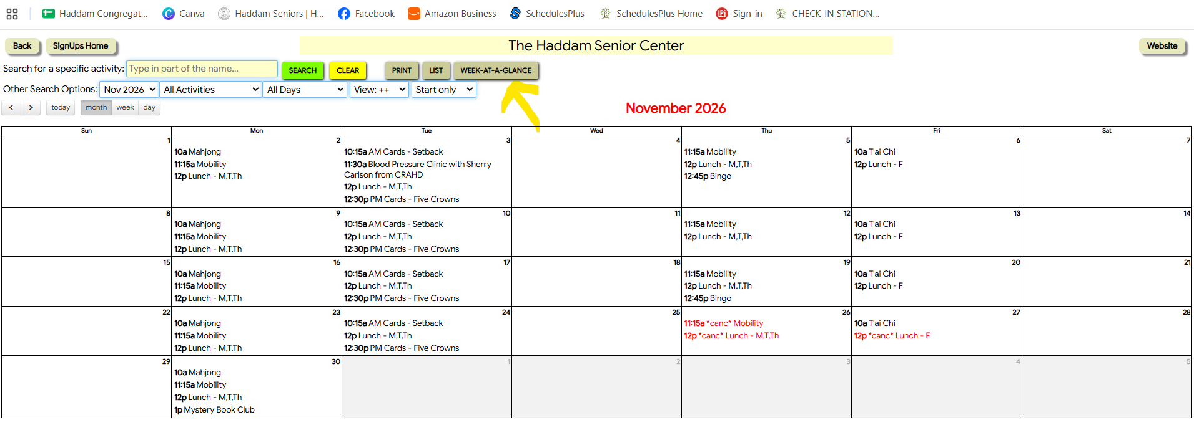

Once selected, you will see all of the events scheduled on a given day for the week. There is also an option to see this view for two weeks by selecting the Show 2 Weeks button. Select the lunch or event on the date you want.

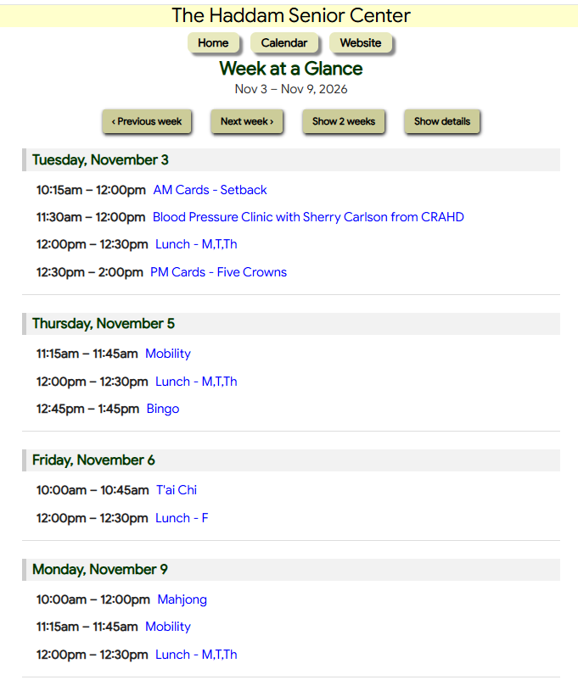
You will get the same confirmation screens as using the calendar.

Once confirmed, it will bring you back to the calendar view and you can follow the same process to register for another lunch or activity, or log out if you are done.

