 Senior Center Activities
(860)345-2480/seniors@haddam.org NOVEMBER 2025
MONDAY | TUESDAY | WEDNESDAY | THURSDAY | FRIDAY
3  10:00am – Mah Jongg  11:15am – Mobility  1:00pm – Club 60 (Community Center) | 4  10:30am – AM Cards  10:30am – 12pm Flu Clinic Presented by Nutmeg Pharmacy  12:30pm – PM Cards | 5  Senior Center  Closed | 6  10:00am – Mah-Jongg  11:15am – Mobility  12:45pm – BINGO | 7  10:00am – T’ai Chi  10:15am - Cards  1:00pm – Board Games
10  10:00am – Mah Jongg  11:15am – Mobility  12:00pm – Pizza and a Movie  “Book Club: The Next Chapter” | 11    Senior Center  Closed | 12  Senior Center  Closed | 13  10:00am – Mah-Jongg  11:15am – Mobility  11:30am Blood Pressure Clinic  12:30pm Flu vs Cold presented by Sherry Carlson from CRAHD | 14  10:00am – T’ai Chi  10:15am - Cards
17  10:00am – Mah Jongg  10:00am – COA  (Old Town Hall)  11:15am – Mobility  1:00pm – Club 60 – Veteran’s Presentation (Community Center) | 18  10:30am – AM Cards  12:00pm Thanksgiving Dinner  From The Kitchen @ Futures Inc  Cost is $4.50/Limited Seating  12:30pm – PM Cards | 19  Senior Center  Closed | 20  10:00am – Mah-Jongg  11:15am – Mobility  12:30pm – November Birthday  Celebration  12:45pm - BINGO | 21  10:00am – T’ai Chi  11:30am – Mini Spa Manicure  *Sign-up Required/$20 Fee  10:15am - Cards
24  10:00am – Mah Jongg  11:15am – Mobility  1:00pm – Floral Workshop  Thanksgiving Centerpiece – Friendsgiving – Bring a Friend!  $20 Haddam Seniors/$25 NR  1:00pm – Mystery Book Club | 25  10:30am – AM Cards  11:30am Blood Pressure Clinic w/Sherry Carlson from CRAHD  12:30pm – PM Cards | 26  Senior Center  Closed | 27  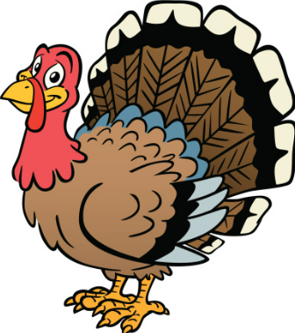Happy Thanksgiving!  Senior Center  Closed | 28  Senior Center  Closed
Key: Regularly scheduled Events Special Events Other Locations Changes/New Events

